Apply for a Scholarship with
Conservation with Crayons
Help Us Send You to Conservation Camp, School, or College! Thanks to everyone who enters our free coloring contests and supports us through donations and merchandise. This allows us to offer scholarships of $250, $500, or $1,000 to kids, teens, and young adults who want to learn more about protecting wildlife, habitat, and conservation.
These scholarships can be used for:
- Summer conservation camps or nature programs
- School field trips to wildlife centers, zoos, or reserves
- College tuition or fees for environmental science, wildlife biology, conservation, or related majors
- Workshops, conferences, or online courses focused on conservation
- A workshop a conservation club wants to attend that requires an entry fee
Who Can Apply
- Ages 5–22 (elementary through college)
- Residents of any country (priority given to applicants with financial need)
- Passionate about animals, nature, or the environment
Award Amounts
- $250 – smaller camps, field trips or a college club that wants to attend a meeting
- $500 – week-long camps or short programs
- $1,000 – multi-week camps, semester fees, or larger tuition support
How to Apply Applications are accepted year-round. We review them quarterly and notify winners within 30 days.
Please email the following to conservewithcrayons@gmail.com (subject line: “Scholarship Application – [Your First Name]”). In a word document or PDF please include:
- Your Information
  - Full name
  - Age and grade/year in school (if applicable)
  - Mailing address
  - Phone number
  - Parent/guardian name and email (required if under 18)
- Program or Tuition Details
  - Name of the camp, school event, course, or college program
  - I attending college what year and major are you
  - Website or brochure link (if available)
  - Exact cost and dates or the program, camp, etc..
  - Amount you are requesting ($250, $500, $1,000, $1,000+)
- Short Essay (200–500 words)
  - Tell us in your own words: “Why do you love nature and conservation and how will this opportunity help you learn more or make a difference?”.
  - Parents or teachers please feel free to help.
- Optional Supporting Materials
  - A photo or scan of your favorite coloring contest entry (if you’ve entered before)
  - Letters of recommendation, report cards, or proof of acceptance (not required, but helpful)
Selection Process Our small team and board review every application fairly. We prioritize:
- Demonstrated passion for conservation
- Financial need
- How the opportunity will help you grow as a future conservationist or a person that respects the natural resources around the world
Winners will receive funds directly (or paid to the program on your behalf) and may be featured (with permission) on our website and social media to inspire others.
Questions? Email us anytime at conservewithcrayons@gmail.com. We’re excited to help you chase your conservation dreams! 🌿🦒🎓
Thank you for caring about our natural ecosystems.
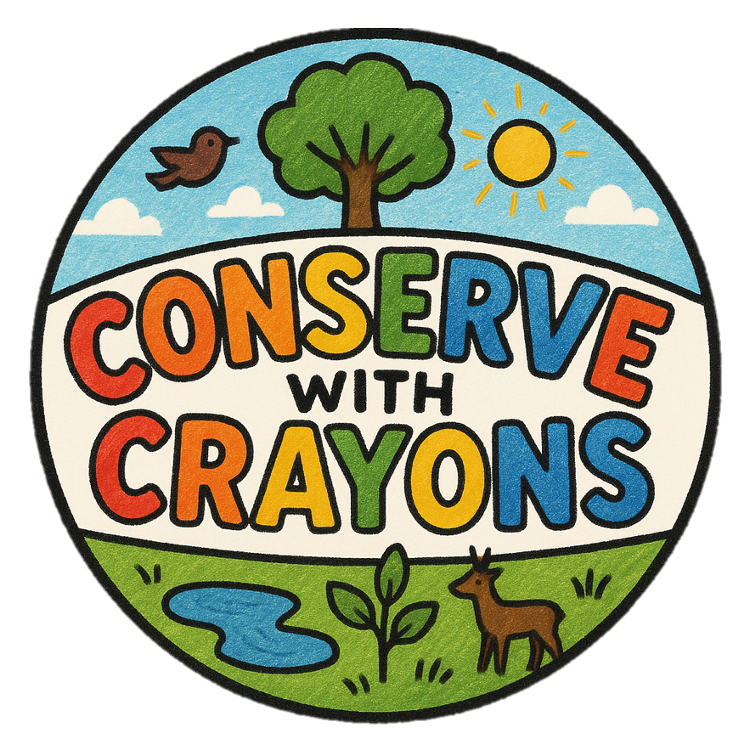
The Conserve with Crayons Team

